INTRODUCTION

Healthcare delivery in Sierra Leone continues to be affected by long and disorganized clinic queues, lost or duplicated paper-based patient records, and delayed responses to emergency cases, particularly within public health facilities. These challenges contribute directly to preventable suffering, overcrowding, and poor continuity of care for patients. As a group, we set out to address this problem through the design of the Salone Wellbodi Clinic System (SWCS), a digital queue and clinic management platform intended to streamline how patients are registered, queued, attended to, and notified throughout their visit to a clinic.

This report presents the complete software design for SWCS as a Digital Public Good, developed in line with the Software Development Life Cycle (SDLC) principles taught in this module. It covers our choice of development methodology, the system's architecture and how its components interact, a fully designed Figma prototype of the system's key screens, our project plan (Gantt chart and network diagram), and our licensing, design quality, and Sustainable Development Goal (SDG) considerations. Our system is designed in direct alignment with SDG 3: Good Health and Well-Being, with the goal of making clinic visits faster, safer, and better organized for both patients and healthcare staff.

- SOFTWARE DEVELOPMENT LIFE CYCLE
For the development of SWCS, we selected the Agile model as our Software Development Life Cycle methodology. We chose Agile for the following reasons:
We worked with a limited budget as a student group, and Agile is well suited for projects where resources are constrained. Although our project involved a significant amount of work covering system architecture, UI/UX prototyping in Figma, UML diagrams, project planning, licensing, and full documentation we were required to deliver all of this within a fixed academic timeframe ending at Week 11. Agile's sprint-based structure allowed us to manage this workload systematically, tackling one area at a time without compromising the quality of any deliverable. The Salone Wellbodi Clinic System also had multiple features that were best built and tested one at a time rather than all at once, and as a group we needed a model that encouraged collaboration, shared responsibility, and continuous feedback all of which are core to how Agile works.
HOW WE DEVELOPED SWCS USING AGILE
We developed the Salone Wellbodi Clinic System in short, focused sprints. Rather than designing and building everything at once, we completed one set of features per sprint, reviewed and tested it as a group, fixed any issues, and then moved on to the next. This meant that at the end of each sprint we always had a working version of part of the system. We used GitHub throughout to track changes, collaborate, and store every version of our work. Figma handled our UI/UX design, and all documentation was updated continuously rather than left to the end.
AGILE STAGES AND WHAT HAPPENED IN EACH
Planning: As a group we defined the problem SWCS was built to solve long clinic queues, lost patient records, and delayed emergency responses in Sierra Leone's public health facilities.
We identified all the features the system needed, assigned roles among ourselves, chose our tools, and mapped out a sprint schedule running from Week 4 to Week 11.
Design: We designed the overall structure of the Salone Wellbodi Clinic System using a four-layer architecture covering the presentation layer, communication layer, application logic, and data layer. We also produced our Figma prototype at this stage, creating over ten screens representing how SWCS looks and feels for real clinic users across the patient, receptionist, doctor, and administrator roles.
Development: We built SWCS sprint by sprint. Sprint 1 covered patient registration and queue management. Sprint 2 handled emergency prioritization and appointment booking. Sprint 3 brought the staff dashboards together, covering the receptionist and doctor interfaces. Sprint 4 integrated everything through the administrator panel and finalized the notification flow. After each sprint we reviewed what had been built as a group before moving forward.
Testing: Testing was carried out continuously after every sprint rather than saved for the end. Each feature of SWCS was checked to make sure it worked as expected, bugs were identified and fixed immediately, and any improvements were carried into the next sprint.
Deployment: All project files including our report, Figma prototype, UML diagrams, and project plan were uploaded to our shared GitHub repository. This served as both our collaboration platform throughout the project and our final delivery point for SWCS.
Maintenance: While the Salone Wellbodi Clinic System is currently a prototype, we have already identified future improvements such as SMS queue notifications, multi-clinic support, and a live database backend all of which would be released as future sprints if SWCS were deployed in a real clinic setting.

- SYSTEM ARCHITECTURE DESIGN
Below is the Component type of System Architecture Design diagram:
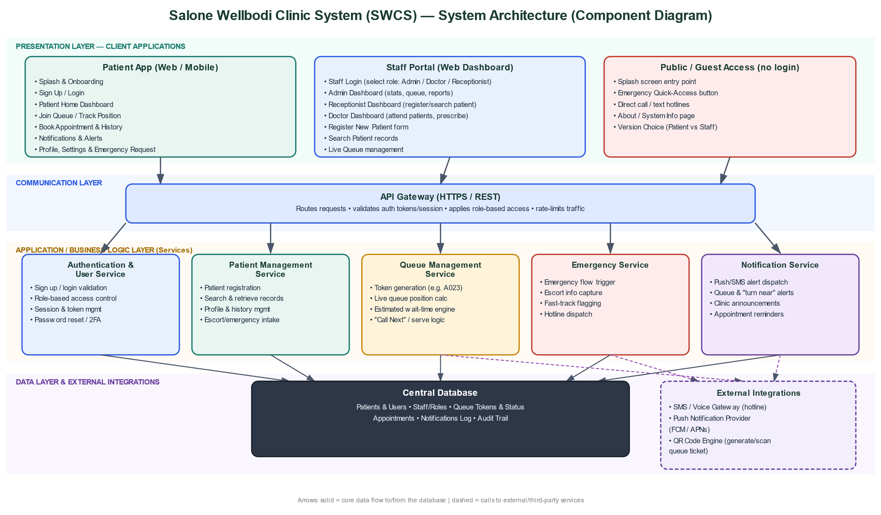

How the Components in Our System Interact
Our system, the Salone Wellbodi Clinic System (SWCS), is built around four layers, and we designed it this way so each part has a clear job and the whole system stays organized and easy to scale.
1. Presentation Layer — Patient App, Staff Portal, and Public/Guest Access
These are the three entry points we designed into our Figma prototype. Our Patient App handles sign-up/login, the patient home screen, queue tracking, appointments, notifications, and profile/emergency requests. Our Staff Portal lets Admins, Doctors, and Receptionists log in by role and use their own dashboards — registering and searching patients, managing the live queue, prescribing medication, and viewing reports.
We also built a Public/Guest Access path that covers everything a person can reach without logging in: the splash screen, the Emergency button, the hotline call/text numbers, and the About page. This is why on the home screen; the Emergency option is always available even before a user signs up or logs in we wanted anyone in a crisis to be able to reach help immediately.
2. Communication Layer — API Gateway
Every request from either the Patient App or the Staff Portal passes through a single API Gateway before it reaches our backend. The Gateway checks the user's session/login token, makes sure they only access what their role allows (for example, a Receptionist cannot open the Doctor's prescribing screen), and then forwards the request to the correct service. We chose this approach because it makes our architecture scalable if we wanted to add another client later, like a USSD/SMS version for users without smartphones, it could connect through the same Gateway without us having to change anything in the services behind it.
3. Application / Business Logic Layer — Our Five Core Services
This is where the actual logic of our system lives. We split it into five services:
Authentication & User Service – validates sign-up and login, manages 2FA and password resets, and enforces role-based permissions.
Patient Management Service – handles patient registration, search, profile/history, and the escort-info forms we designed (Form 1 and Form 2 in our prototype).
Queue Management Service – generates queue tokens (e.g., A023), calculates queue position and estimated wait time, and powers the "Call Next" action on the Receptionist and Doctor dashboards.
Emergency Service – triggered by the Emergency button; captures the escort's details and flags the case so it can be fast-tracked.
Notification Service – sends alerts such as "your turn is near," "token confirmed," delay notices, and appointment reminders to the patient's Notifications screen.
These services don't talk to each other directly — they interact through the Gateway and the shared database. For example, when a Receptionist registers a new patient, the Patient Management Service saves the record, the Queue Management Service issues that patient a token, and the Notification Service immediately sends an alert to that patient's app — all from one action on the Receptionist's side.
4. Data Layer — Central Database
All five services read from and write to one shared database, which stores patients, staff/roles, queue tokens, appointments, the notifications log, and an audit trail. We centralized our data this way so that, for instance, when a Receptionist registers a patient, the patient's "My Queue" screen updates in real time on their own device, since both sides are pulling from the same source of truth.
5. External Integrations
Our system also connects to a few outside services to function properly: the Notification Service uses a push/SMS provider to actually deliver the alerts, the Emergency Service uses an SMS/voice gateway to handle the hotline numbers shown on our Emergency screen, and the Queue Management Service uses a QR code engine to generate the scannable ticket shown on our Queue Ticket screen.
A worked example we use to demonstrate the flow end-to-end: a patient opens the app → the Authentication Service verifies their login → the Patient Home screen requests their queue status from the Queue Management Service through the Gateway → the Queue Service reads and writes the token data in the database → the Notification Service then pushes a "Token Confirmed" alert straight back to the screen the patient is already looking at.
This is how we ensured our four layers and five services work together as one connected system rather than separate disconnected parts.
- PROTOTYPE DEVELOPMENT
Screenshots of the Figma screens making up the entire prototype below:
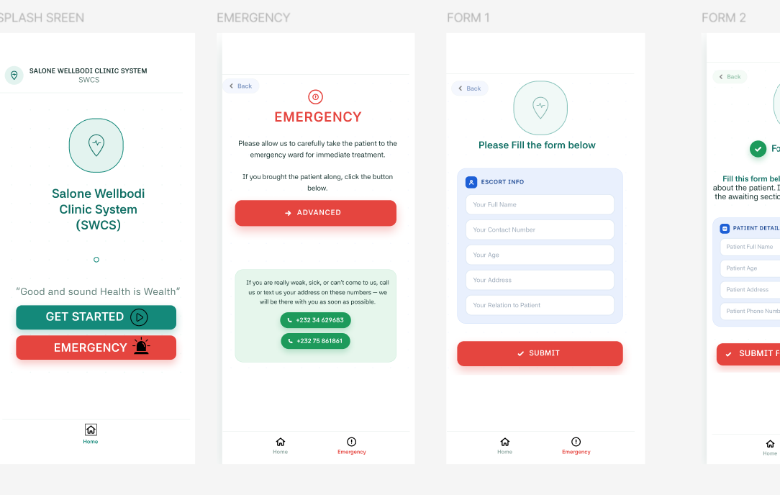
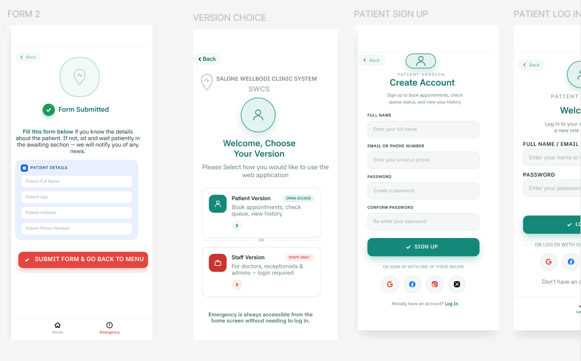
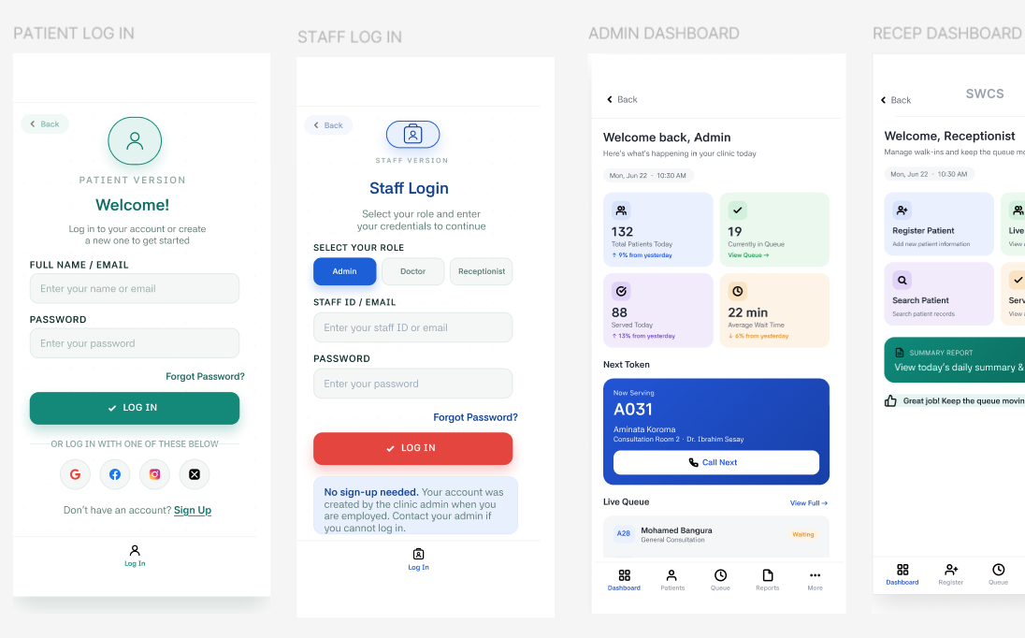

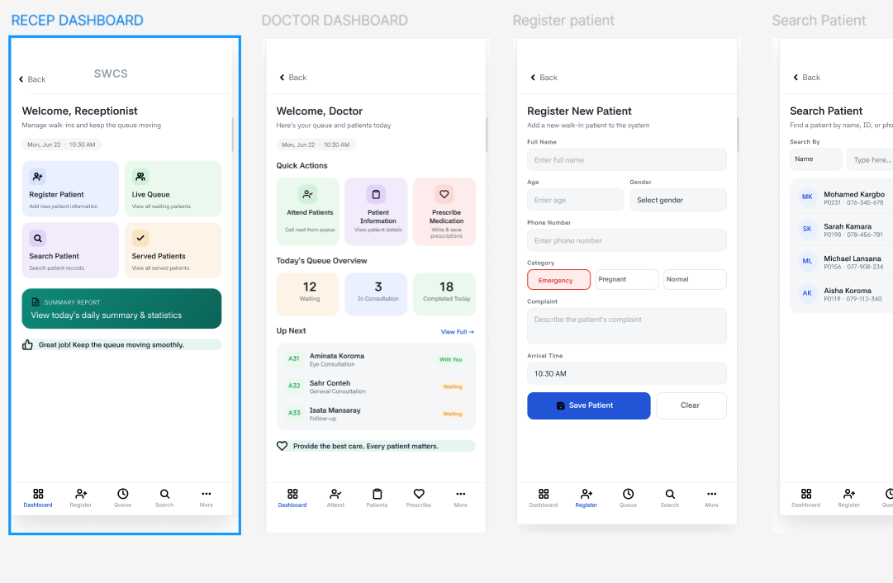
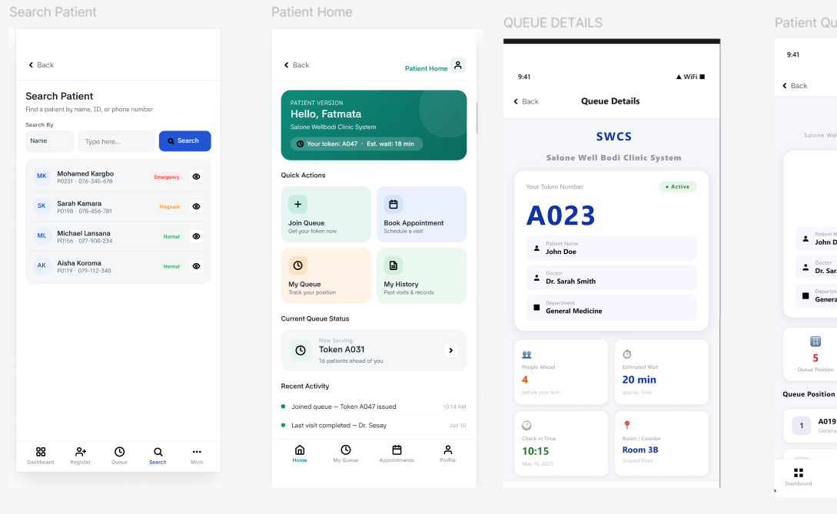

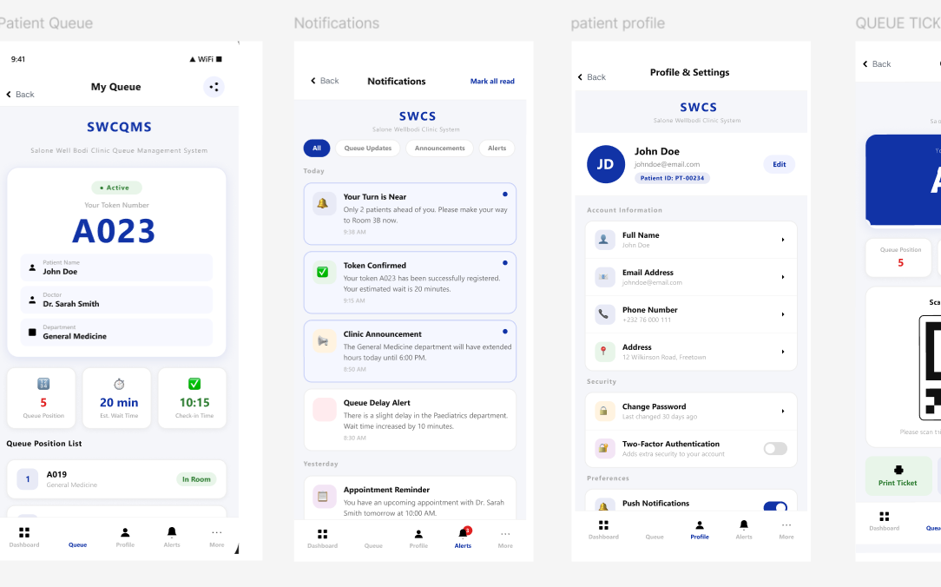
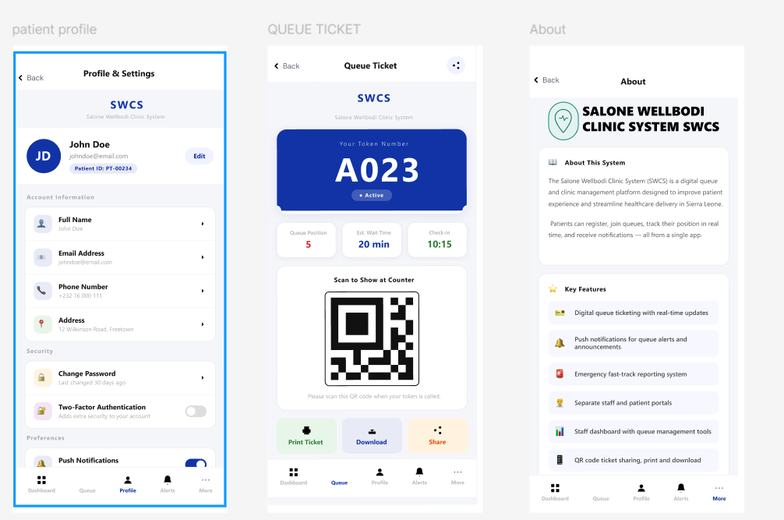
Figma link:
https://www.figma.com/design/KT3hMkUz1fN2jZ05dKkT65/ASSIGNMENT-2?node-id=0-1&p=f&t=hlUAMoOu1wzMlPgs-0

- GUITHUB
Guithub link:
https://github.com/Kaisamba-JP/SOFTWARE_ENGINEERING_PROG102_BSEM1201F_GROUP4_SWCS.git
SCREENSHOTS OF GITHUB:
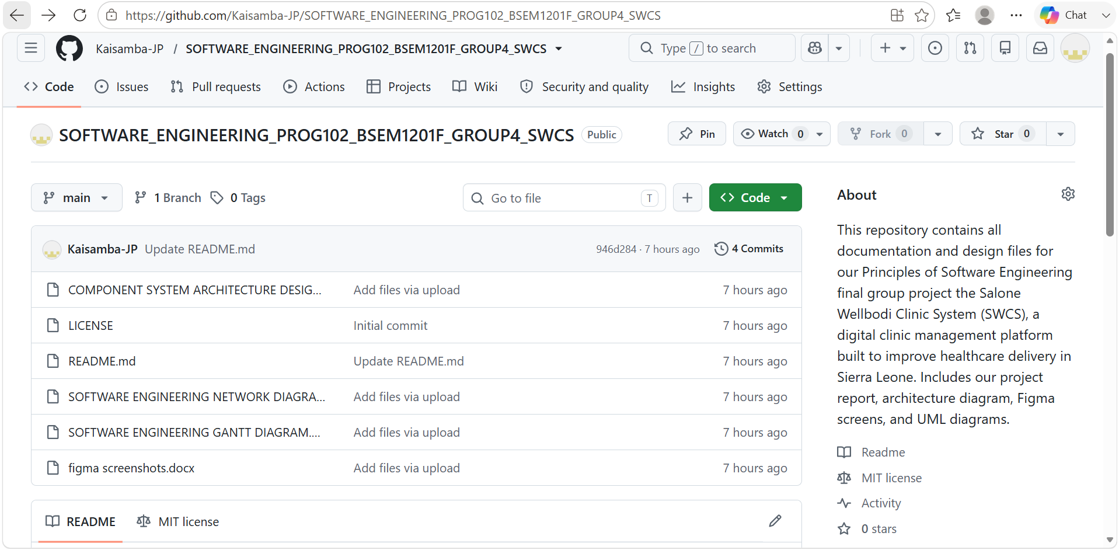
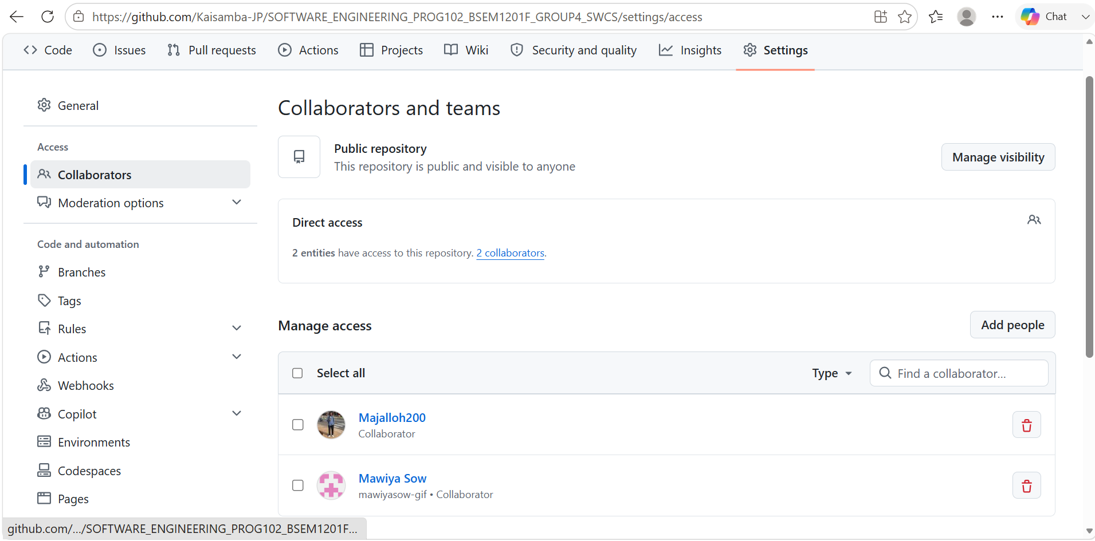

- PROJECT PLAN
Below is the project plan for our “Salone Wellbodi Clinic System":
1. Planning & Research 2. Assembling Requirements 3. System Architecture Design 4. Prototype Development (Figma Screens) 5. GitHub Documentation 6. Testing & Correction and 7. Final Report Submission.
Below is the Activity chart for the project plan above:
CODE | Tasks | Duration [Days- Week] | Dependencies
1 | Planning & Research | 6 days (Week 4) | none
2 | Assembling Requirements | 6 days (Week 5) | 1
3 | System Architecture Design | 12 days (Week 6&7) | 1&2
4 | Prototype Development (Figma Screens) | 24 days (Week 7-10) | 2&3
5 | GitHub Documentation | 18 days (Week 9-11) | 3&4
6 | Testing & Correction | 18 days (Week 8-10) | 4
7 | Final Report Submission | 6 days (Week 11) | 3,4,5,6

Gantt Chart — Salone Wellodi Clinic Queue Management System
Below is the Gantt chart:
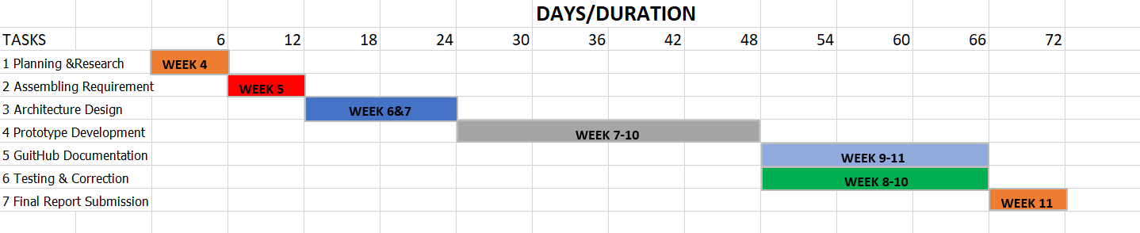
A Gantt chart is a visual timeline that shows when each task in a project starts, how long it runs, and how tasks overlap or follow one another.
In our chart the vertical axis lists the project tasks, while the horizontal axis represents the days/duration of the project. Each task is shown as a colored horizontal bar, the bar's position shows when it starts, and its length shows how long it runs.
The chart maps all 7 project tasks across a 72-day timeline (Weeks 4–11):
Task 1 — Planning & Research: Week 4 (Days 0–6)
Task 2 — Assembling Requirement: Week 5 (Days 6–12)
Task 3 — Architecture Design: Weeks 6&7 (Days 12–24)
Task 4 — Prototype Development: Weeks 7–10 (Days 24–48)
Task 5 — GitHub Documentation: Weeks 9–11 (Days 48–66)
Task 6 — Testing & Correction: Weeks 8–10 (Days 48–66)
Task 7 — Final Report Submission: Week 11 (Days 66–72)
Tasks 1–4 run sequentially, each starting only after the previous one ends. Tasks 5 and 6 runs in parallel both occupying Days 48–66; meaning GitHub Documentation and Testing & Correction happen simultaneously rather than one after the other. The project then converges on Task 7, closing out at Day 72.
This timing matches the ES/EF values from the network diagram exactly, confirming that both project management tools tell the same story about the schedule.
This timing matches the ES/EF values from the network diagram exactly, confirming that both project management tools tell the same story about the schedule.

Risk Management
Risk management involves identifying problems that could delay or disrupt a project before they happen, and having a plan ready to deal with them. Looking at our Gantt chart, the following risks were identified:

1. Scope Creep (Task 4 — Prototype Development, Weeks 7–10): This is the longest task in our chart, running from Day 24 to Day 48. The risk here is that the team keeps adding new features or screens beyond what was originally planned, stretching the task beyond Week 10 and pushing everything after it — GitHub Documentation, Testing, and Final Submission — off schedule. To manage this, we agreed on a fixed list of features before development began and will not add new one’s mid-sprint.
2. Team Member Unavailability: Since Tasks 5 and 6 (GitHub Documentation and Testing & Correction) run in parallel between Days 48–66, both require active team members working at the same time. If a member becomes unavailable during this window, both tasks are affected simultaneously. To manage this, responsibilities are shared across the group so no single task depends on one person alone.
3. Time Underestimation: Task 3 (Architecture Design, Weeks 6&7) and Task 2 (Assembling Requirements, Week 5) are short, back-to-back tasks. If either runs over, it delays Task 4, which is already the heaviest task. To manage this, we built no overlapping buffer between early tasks, so the team must strictly stick to each week's deadline.
4. Late Final Submission (Task 7 — Week 11): Task 7 sits at the very end with no buffer after Day 72. Any delay in Tasks 5 or 6 directly pushes the submission past the deadline. To manage this, we set an internal soft deadline of Day 70 for completing Tasks 5 and 6, giving a small two-day margin before the actual submission date.

Network Diagram — Salone Wellbodi Clinic System (SWCS)
Below is the diagram:
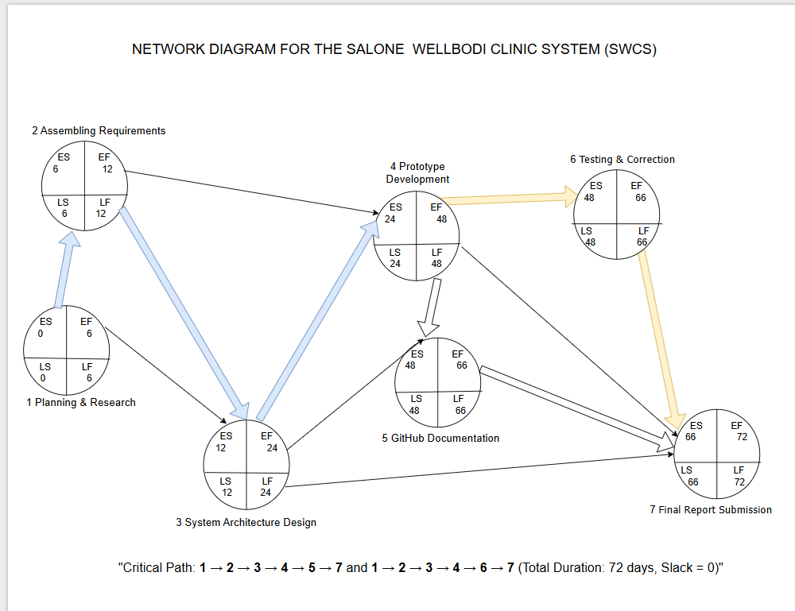
Our network diagram above maps out all 7 tasks of the SWCS project, showing their dependencies and timing from start to finish. Each task is represented as a circle (node) divided into four quadrants displaying the ES (Early Start) and EF (Early Finish) in blue, and the LS (Late Start) and LF (Late Finish) in red/maroon. The arrows between nodes show the order in which tasks must be completed before the next one can begin.
The project kicks off with Node 1 Planning & Research (ES=0, EF=6), which feeds directly into Node 2 Assembling Requirements (ES=6, EF=12). From Node 2, the work branches one arrow goes to Node 3 System Architecture Design (ES=12, EF=24), and a shortcut arrow goes directly to Node 4, though that arrow carries slack and is not critical.
Node 3 then feeds into Node 4 Prototype Development (ES=24, EF=48), which is the project's heaviest task, running from Day 24 to Day 48.
From Node 4, the diagram splits into two parallel branches:
Node 5 — GitHub Documentation (ES=48, EF=66)
Node 6 — Testing & Correction (ES=48, EF=66)
Both run simultaneously between Days 48 and 66, before converging on Node 7 Final Report Submission (ES=66, EF=72), which closes the project at Day 72.
Since every node in our diagram has LS = ES and LF = EF, the slack across the entire network is zero, giving us two critical paths:
1→2→3→4→5→7 and 1→2→3→4→6→7, both totalling 72 days. The shared trunk (1→2→3→4) is highlighted in blue, the GitHub Documentation branch in white/bold, and the Testing & Correction branch in gold/yellow — making both critical paths clearly visible. The non-critical arrows (1→3, 2→4, and 3→7) are left as plain thin lines since they carry slack of 6, 12,
- License, Design Quality & SDG Relevance
Software License
My group members and I have chosen to release the Salone Wellbodi Clinic System (SWCS) under the MIT License. We selected this license because it is simple, open, and perfectly suited for a Digital Public Good. It allows healthcare organizations, government bodies, NGOs, and developers to freely use, modify, and distribute our system without legal or financial restrictions, as long as our original copyright notice is kept. Unlike the GNU GPL, the MIT License places no conditions on how others adapt or integrate our system, which means the SWCS can be adopted as widely as possible, maximizing its real-world impact on healthcare delivery in Sierra Leone and beyond. Our license file is included in our GitHub repository as LICENSE.txt.

Design Quality (UI/UX)
My group members and I designed the SWCS (Salone Wellbodi Clinic System) interface with simplicity and clarity in mind. We used a consistent teal-green color scheme across the core screens visible on the splash screen, the "Get Started" button, headers like "Welcome, Receptionist" and "Welcome, Doctor," and the active icons on the bottom navigation bar to create a calm, professional, and visually unified healthcare experience. We reserved red specifically for urgency, using it only on the Emergency button and Emergency screen, so that patients can instantly recognize it as different from the rest of the system without us needing to add any extra explanation.
Every screen in our prototype has a clear title at the top (e.g., "Form 1," "Queue Details," "Patient Profile," "Search Patient"), along with a consistent back arrow, so users always know where they are in the app and how to return to the previous screen. Our buttons are bold, full-width, and color-coded by action green for confirming or submitting (e.g., "Submit," "Sign Up," "Save Patient"), red for emergency or urgent actions, and blue for staff-related actions like "Call Next" which makes it easy for even first-time users to identify what to tap without confusion.
The layout across our screens is clean and card-based: information is grouped into clearly separated white cards (such as the Queue Status card, Patient Details card, and Account Information card), so each screen only shows what's relevant to that step instead of overwhelming the user with everything at once. We also kept our bottom navigation bar consistent across the Patient, Receptionist, and Doctor versions of the app using the same icon style and position for Dashboard, Queue, Profile, and Alerts so that regardless of which role a person is logged in as, the navigation pattern feels familiar.
We prioritized ease of use throughout, since our target users include patients and visitors of all backgrounds and education levels, some of whom may not be used to digital systems.

That's why we avoided technical jargon on screens like the Patient Home and Queue Ticket, used simple labels like "My Queue," "Book Appointment," and "Scan to Show at Counter," and made sure the Emergency option is always visible from the home screen without requiring login, so help is never more than one tap away.

SDG Relevance SDG 3: GOOD HEALTH AND WELL-BEING
My group members and I designed the SWCS in direct response to the healthcare challenges facing Sierra Leone, making it a natural fit for SDG 3: Good Health and Well-Being.
Clinics in our country struggle daily with overcrowding, dangerously long waiting times, lost paper records, and delayed emergency responses, all of which contribute to preventable suffering and death. Our system addresses these problems head-on. The emergency feature ensures critical patients are attended to immediately, reducing preventable deaths. Digital queue management reduces overcrowding, lowering the risk of disease transmission in waiting areas. Our digital record system replaces unreliable paper files, improving continuity and quality of care. Features like appointment booking, pharmacy requests, and visitor tracking make healthcare more organized and accessible to the wider community. Together, these features make the system a practical digital tool that directly advances SDG 3's vision of healthy lives and well-being for all.

CONCLUSION

In undertaking this project, our group was able to apply the core principles of software engineering to a real and pressing problem affecting healthcare delivery in our country. By adopting the Agile model, we broke down a demanding project covering system architecture, UI/UX prototyping, project planning, and documentation into manageable stages that we could design, review, and refine within the timeframe given to us.
Through the Salone Wellbodi Clinic System, we designed a four-layer architecture, translated into a working Figma prototype of over ten screens covering the patient, receptionist, doctor, and administrator experience. Our project plan, represented through a Gantt chart and network diagram, allowed us to map task dependencies and identify the critical path, while our choice of the MIT License ensures the system can be freely adopted by clinics, NGOs, and government bodies seeking to improve healthcare access.
While SWCS remains a prototype at this stage, it demonstrates a practical and scalable approach to reducing overcrowding, improving record-keeping, and speeding up emergency response directly supporting SDG 3's vision of healthy lives and well-being for all. This project has given our group valuable hands-on experience in designing, planning, and documenting a complete software system from the ground up.

REFERENCES

Beck, K., Beedle, M., van Bennekum, A., Cockburn, A., Cunningham, W., Fowler, M., Grenning, J., Highsmith, J., Hunt, A., Jeffries, R., Kern, J., Marick, B., Martin, R.C., Mellor, S., Schwaber, K., Sutherland, J. and Thomas, D. (2001) Manifesto for Agile Software Development. Snowbird, Utah: Agile Alliance.
Sommerville, I. (2016) Software Engineering. 10th edn. Harlow: Pearson Education.
United Nations (2015) Transforming Our World: The 2030 Agenda for Sustainable Development. New York: United Nations Department of Public Information.
Digital Public Goods Alliance (2022) Digital Public Goods Standard, Version 1.1. Oslo: Digital Public Goods Alliance Secretariat.
Pressman, R.S. and Maxim, B.R. (2020) Software Engineering: A Practitioner's Approach. 9th edn. New York: McGraw-Hill Education.
Nielsen, J. and Budiu, R. (2013) Mobile Usability. Berkeley: New Riders Publishing.

